1.To print welcome in java

public class myfirstprogram

{

public static void main(String arg[])

{

System.out.println("welcome");

}

}

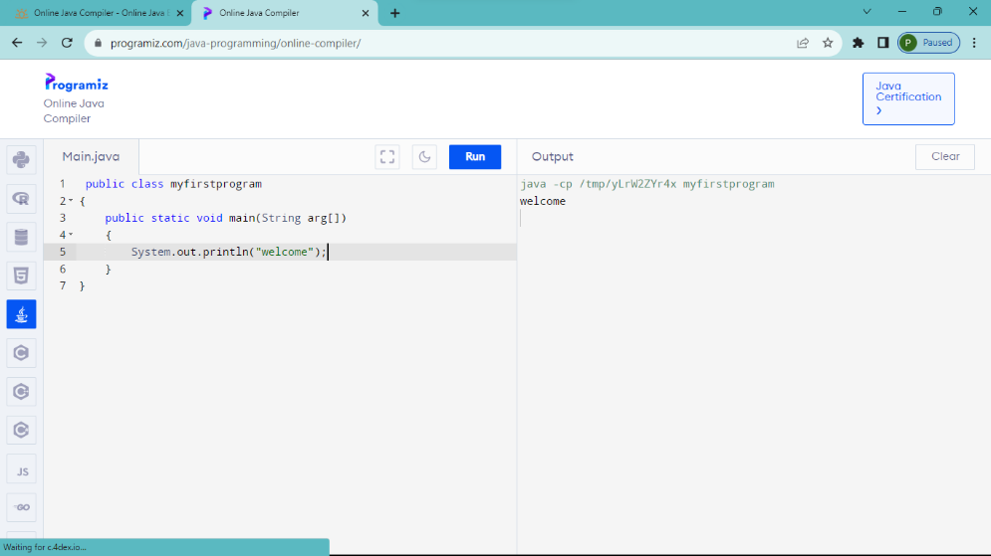

2.Addition of two numbers

import java.util.\*;

public class addition

{

public static void main(String args[])

{

Scanner s=new Scanner(System.in);

int a,b,c;

System.out.println("enter 1st number");

a=s.nextInt();

System.out.println("enter 2nd number");

b=s.nextInt();

c=a+b;

System.out.println("sum ="+c);

}

}

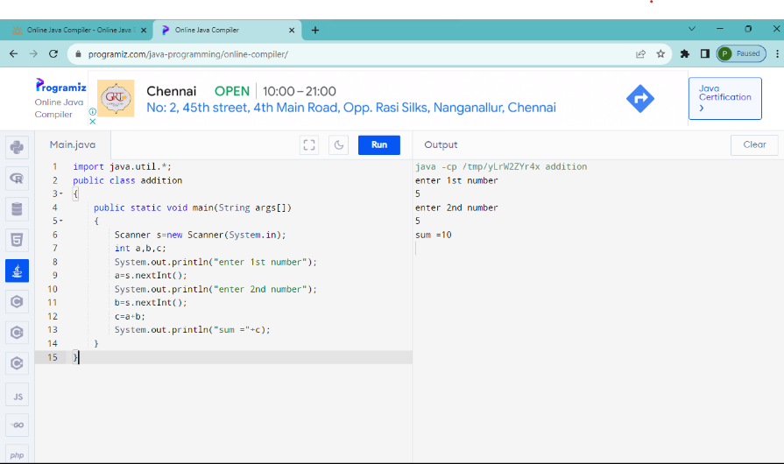

3.To find simple interest

import java.util.\*;

public class simpleinterest

{

public static void main(String args[])

{

Scanner s=new Scanner(System.in);

float p,r,t,si;

System.out.println("enter p");

p=s.nextInt();

System.out.println("enter r");

r=s.nextInt();

System.out.println("enter t");

t=s.nextInt();

si=(p\*r\*t)/100;

System.out.println("simple interest="+si);

}

}

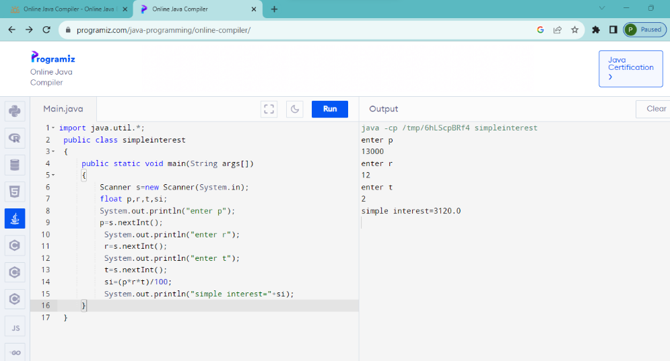

4.Odd or Even

import java.util.\*;

public class oddeven

{

public static void main(String args[])

{

Scanner s=new Scanner(System.in);

int num;

System.out.println("enter number");

num=s.nextInt();

if(num%2==0)

System.out.println("it is even");

else

System.out.println("it is odd");

}

}

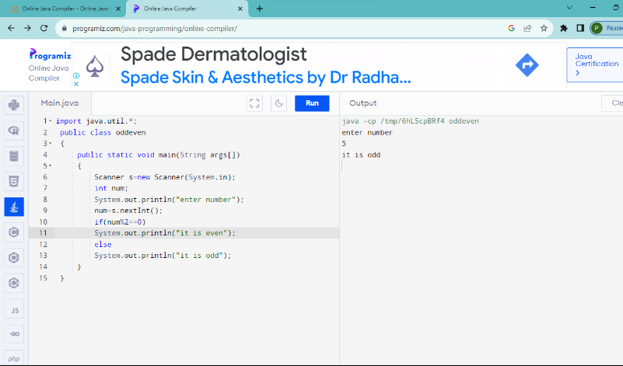

5.Leap year or not

import java.util.\*;

public class leapyear

{

public static void main(String args[])

{

Scanner s=new Scanner(System.in);

int year;

System.out.println("enter an year");

year=s.nextInt();

if(((year%4==0)&&(year%100!=0))||(year%400==0))

System.out.println("it is leap year");

else

System.out.println("it is not leap year");

}

}

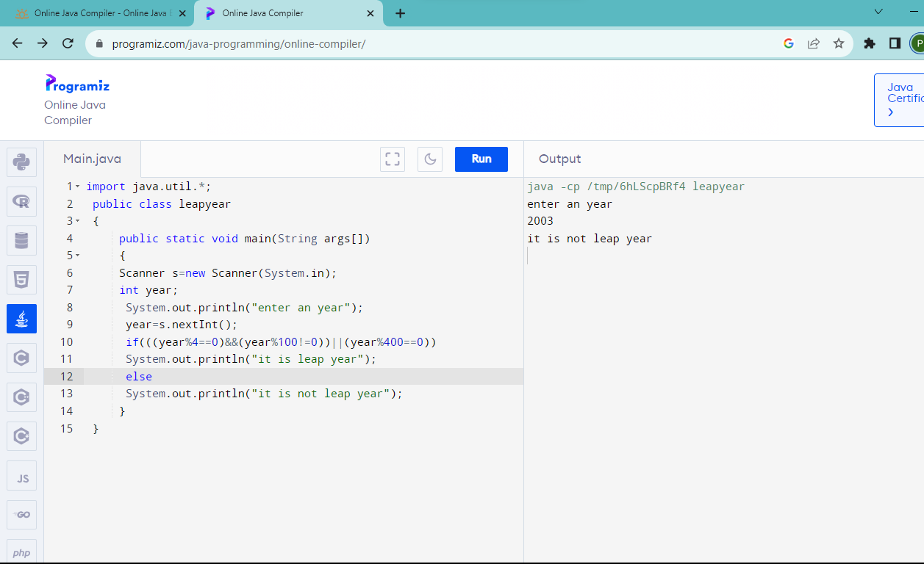

6.Eligible to vote

import java.util.\*;

public class vote

{

public static void main(String args[])

{

Scanner s=new Scanner(System.in);

int age;

System.out.println("enter age");

age=s.nextInt();

if(age>=18)

System.out.println(age + "eligible to vote");

else

System.out.println(age + "not eligible to vote");

}

}

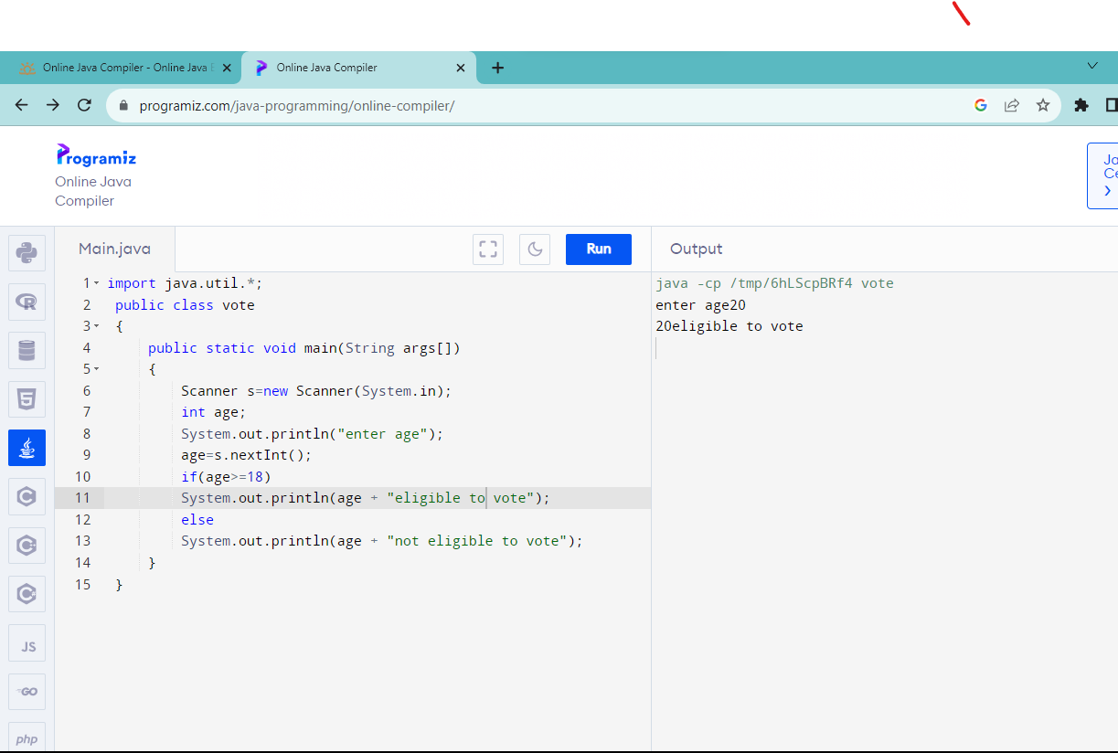

7.positive,negative,zero

import java.util.\*;

public class number

{

public static void main(String args[])

{

Scanner s=new Scanner(System.in);

int num;

System.out.println("enter a number");

num=s.nextInt();

if(num>0)

System.out.println(num+"is positive");

else if(num==0)

System.out.println(num+"is zero");

else

System.out.println(num+"is neagative");

}

}

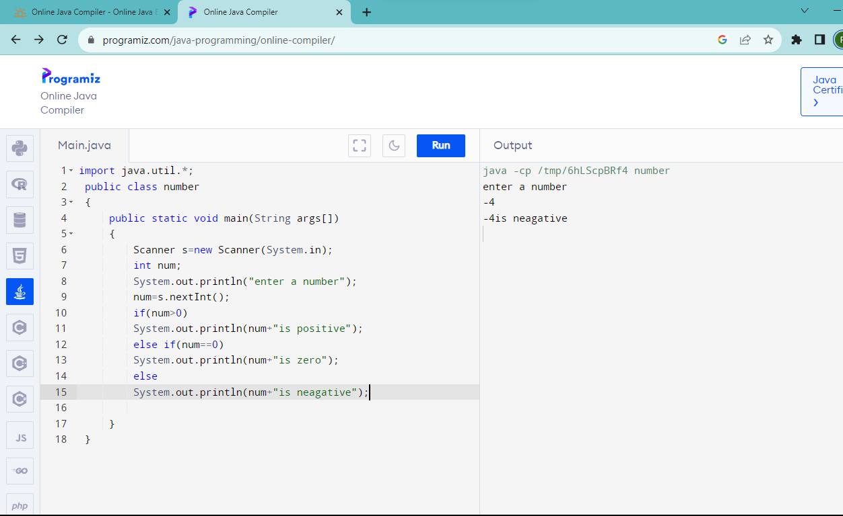

8.College name and dept

import java.util.\*;

public class name

{

public static void main(String args[])

{

Scanner s=new Scanner(System.in);

String clg,dept;

System.out.println("enter college name");

clg=s.next();

System.out.println("enter department name");

dept=s.next();

}

}

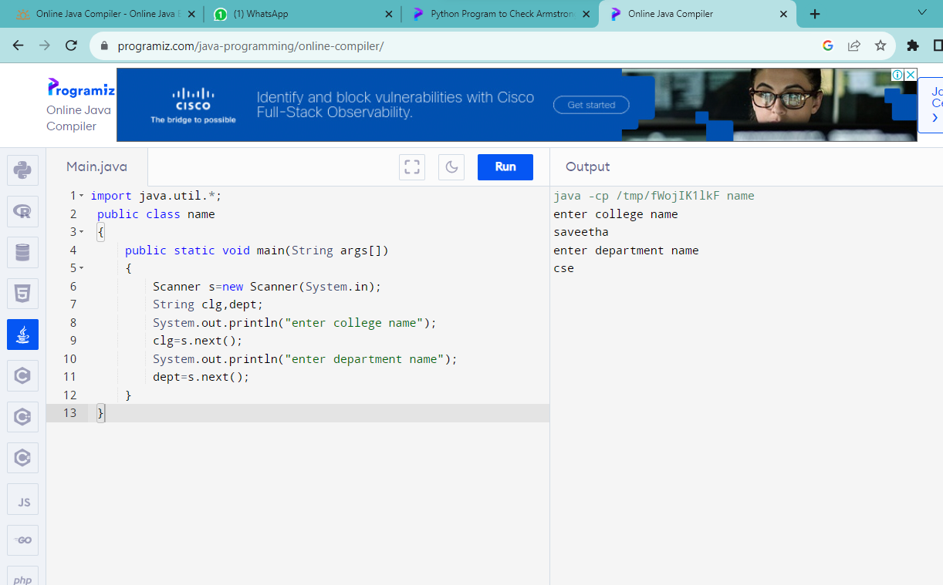

9.Sum of number

public class sum

{

public static void main(String[] args)

{

int i, num = 5, sum = 0;

for(i = 1; i <= num; ++i)

{

sum = sum + i;

}

System.out.println("Sum is = " + sum);

}

}

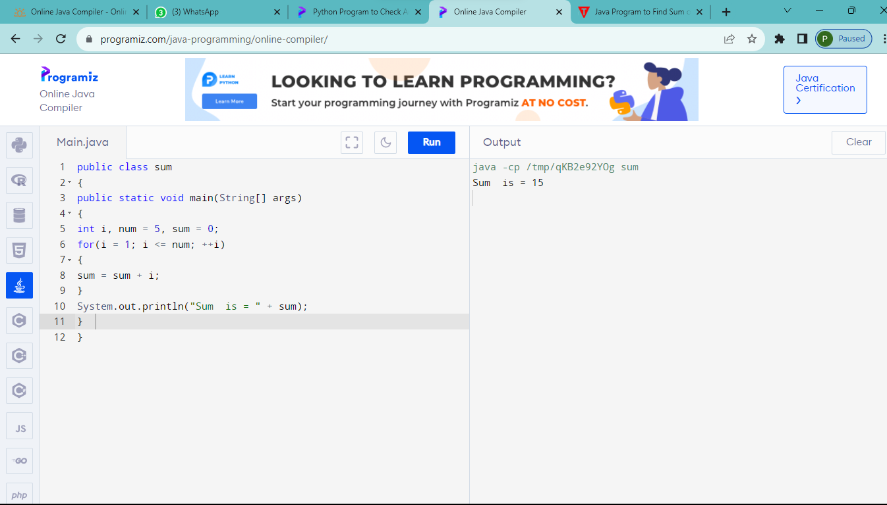

10.factorial

import java.util.\*;

public class factorial

{

public static void main(String args[])

{

Scanner s=new Scanner(System.in);

int i,n,fact=1;

System.out.println("enter number");

n=s.nextInt();

for(i=1;i<=n;i++)

fact=fact\*i;

System.out.println(fact);

}

}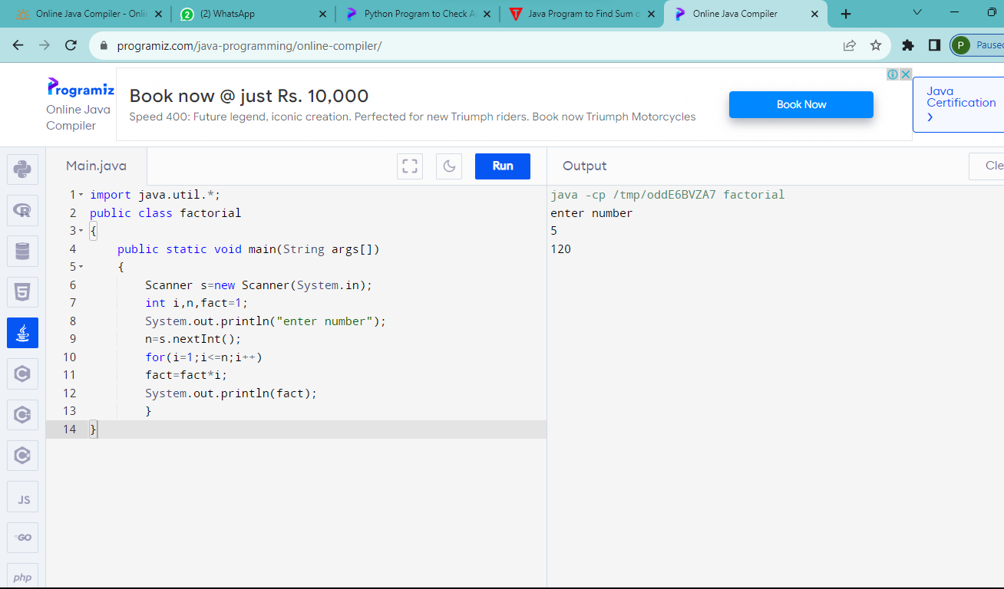

11.Prime number

import java.util.\*;

public class prime

{

public static void main(String args[])

{

Scanner s=new Scanner(System.in);

int i,n,count=0,sum=0;

System.out.println("enter number");

n=s.nextInt();

for(i=1;i<=n;i++)

if(n%i==0)

count++;

if(count==2)

System.out.println("is prime");

else

System.out.println("is not prime");

}

}

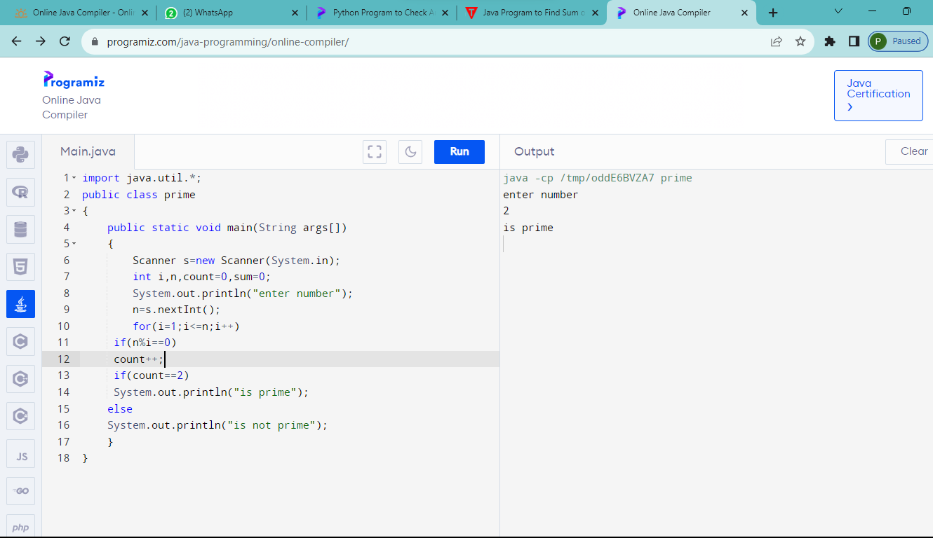

12.Reverse

import java.util.\*;

public class reverse

{

public static void main(String args[])

{

Scanner s=new Scanner(System.in);

int n,rev=0,rem;

System.out.println("enter number");

n=s.nextInt();

while(n!=0)

{

rem=n%10;

rev=rev\*10+rem;

n=n/10;

}

System.out.println(rev);

}

}

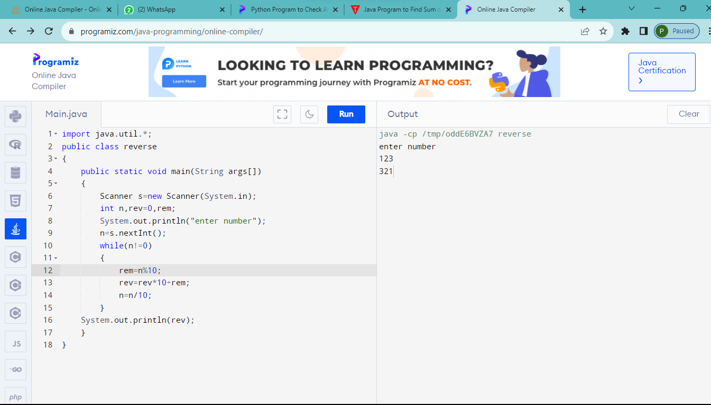

13.palindrome

import java.util.\*;

public class palindrome

{

public static void main(String args[])

{

Scanner s=new Scanner(System.in);

int num,rev=0,rem;

System.out.println("enter number");

num=s.nextInt();

while(num!=0)

{

rem=num%10;

rev=rev\*10+rem;

num=num/10;

}

if(rev==num)

System.out.println("palindrome");

else

System.out.println("not palindrome");

}

}

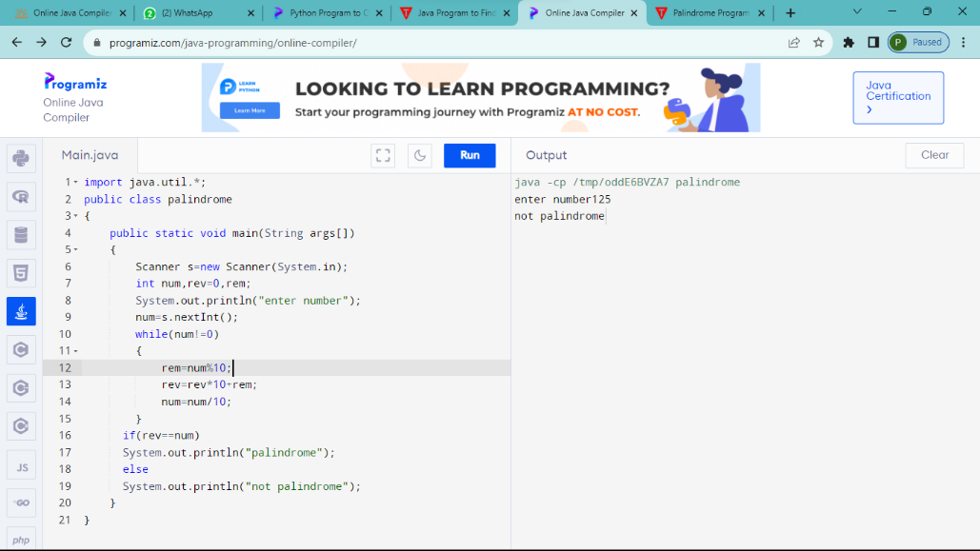

14.Armstrong number

import java.util.Scanner;

class ArmstrongNum {

public static void main(String[] args) {

int temp, digit, Sum = 0,num;

System.out.println("Enter the number:");

Scanner sc = new Scanner(System. in );

num = sc.nextInt();

temp = num;

while (num!= 0)

{

digit = num % 10;

Sum += Math.pow(digit, 3);

num /= 10;

}

if(Sum == temp)

System.out.println( " Armstrong number");

else

System.out.println( " not an Armstrong number");

}

}

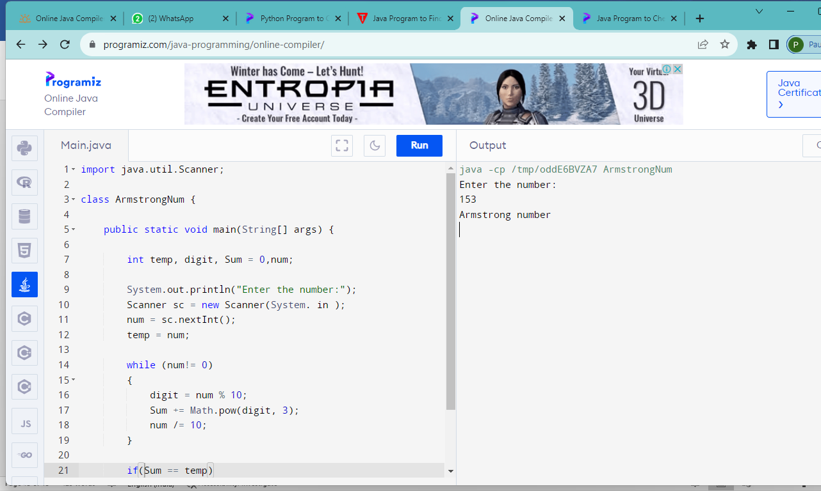

15.fibonacci series

import java.util.Scanner;

public class Fibonacci

{

public static void main(String[] args)

{

int n, a = 0, b = 0, c = 1;

Scanner s = new Scanner(System.in);

System.out.print("Enter value of n:");

n = s.nextInt();

System.out.print("Fibonacci Series:");

for(int i = 1; i <= n; i++)

{

a = b;

b = c;

c = a + b;

System.out.print(a+" ");

}

}

}

